CHAPTER 7: Chemical reactions
Worksheet 7.5

Airship up in flames
Science Quest 9: pages 272–3
Student: Class:
On 6 May 1937 the world's largest flying machine burst into flames over a crowd of onlookers. The flying machine was the luxurious Hindenburg airship. The fire claimed the lives of at least 30 of the people on board and also severely damaged the reputation of one of the most abundant chemical elements. At the time, it was believed that the flammable gas that filled the airship was responsible for the disaster; however, since then scientists have come to a different conclusion.
1. What is the name of the gaseous element that filled the Hindenburg airship?
2. Use the Hindenburg disaster weblink in your eBookPLUS to research the disaster.
(a) Take notes about what witnesses to the disaster said.
(b) Select a photo or diagram of the disaster.
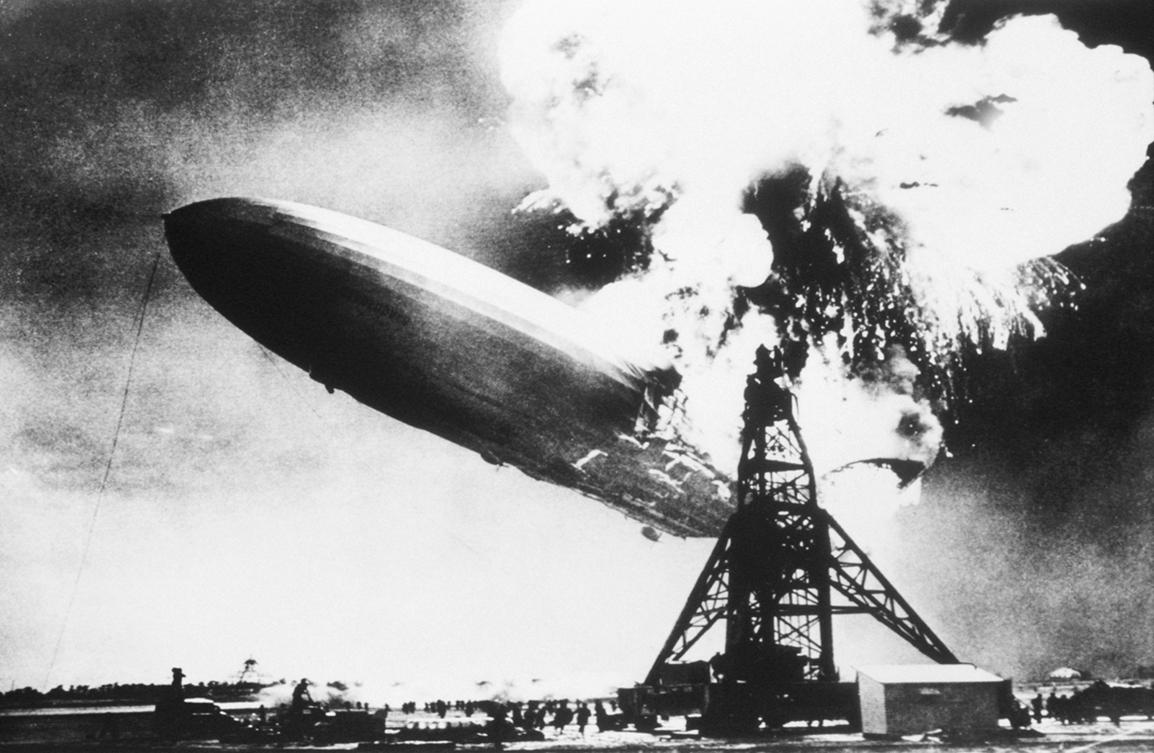
(c) Make a list of the evidence that suggests the gas that filled the airship was not responsible for the blast.
- The Hindenburg exploding, 6 May 1937
3. Write a newspaper article from the point of view of a witness to the disaster (who is a scientist). In the article, include:
● a description of your thoughts and emotions at the time
● a description of what you saw and heard
● the accepted scientific reasons why the airship burst into flames
● a photo or other diagrams
● an appropriate headline.

